***RH124 Summary***

***Ch2: Accessing the command Line:***

* **Default shell for users in Red Hat Enterprise Linux is the GNU Bourne-Again Shell (BASH)**
* ***Semicolon ;* can be used as a *command separator***

|  |  |
| --- | --- |
| Command or option | Description |
| Command - - help | shows the appropriate options for command |
| Exit or ctrl + d | terminates the current shell session |
| clear or ctrl + I | *clear the shell but without deleting previous commands* |
| reset | *clear the shell with deleting previous commands* |
| ls | *List the files and directories in bare format* |
| date | *Showing the date and time* |
| Ctrl + Alt + Up or Ctrl + Alt + Down | *switching between workspaces* |
| Ctrl + Alt + L | *Locking the screen* |
| Ctrl + Alt + Q | *shut down the system* |
| passwd | to change the user’s password |
| file | displays the type of this file |
| head  tail  EX: head -n 3 /etc/passwd | **display the beginning and end of a file respectively (10 lines by default).**  **–n option allows a different number of lines to be specified** |
| wc [ -l | -w | -c] | **counts lines, words and characters in a file** |
| history | **displays a list of previously executed commands**   * **To execute a command from history:**   + **Put “!” Followed by number of command.** |

***Ch3: Managing Files From the Command line:***

|  |  |
| --- | --- |
| ***Location*** | ***Purpose*** |
| ***/usr*** | *As in WINDOWS. Installed software, shared libraries, include files, and static read -only program data.*  *Important sub-directories include:*   * */usr/bin : User commands.* * */usr/sbin : System administration commands.* * */usr/local: Locally customized software.* |
| ***/etc*** | *Configuration files (persistent content )specific to this system* |
| ***/var*** | *Files that dynamically change (e.g. cache directories, log files,…….)* |
| ***/run*** | *Runtime data for processes started since last boot. Data saved from a program from last reboot.* |
| ***/root*** | *Home directory for the administrative superuser, root* |
| ***/tmp*** | *A writable space for temporary files . Files are deleted after being saved 10 days in this*  *directory* |
| ***/boot*** | *Files needed in order to start the boot process* |
| ***/dev*** | *Contains special device files which are used by the system to access hardware* |
| ***/home*** | *Home directories where regular users store their personal data and configuration files* |

|  |  |
| --- | --- |
| Command or option | Description |
| pwd | It displays the full path (absolute path) name of the current location |
| ls |  |
| cd | Change directory / cd - changes directory to the previous dir the user was in |
| touch | creating new files |
| grep | **globally** search a **regular expression** and **print**) |
| cat | **view, create, and concatenate files. It reads files sequentially and print it** |
| echo | It displays the full path (absolute path) name of the current location |
| *$(command)* | It allows the output of a command to replace the command itself |

|  |  |  |
| --- | --- | --- |
| ***Activity*** | ***Single Source*** | ***Multiple Source*** |
| ***Copy file*** | cp file1 file2 🡪 copying contents of file1into file2 | cp file1 file2 dir 🡪 copy files(1,2 and 3) to directory dir |
| ***Move file*** | mv file1 file2 🡪 It is used to rename file1 by file2 | mv file1 file2 file3 dir 🡪 move files(1,2 and 3) to director dir |
| ***Remove file*** | rm file1 🡪 delete the file | rm –f file1 file2 file3 🡪 use caution with “force” option; you will not be prompted to confirm your action |
| ***Create directory*** | mkdir dir 🡪 it is used to create a single directory | mkdir –p par1/par2/dir 🡪 it is used to create a new directory (using absolute path) |
| ***Copy directory*** | cp –r dir1 dir2 🡪 copy the dir1 at dir2 (-r à copy directory recursively) | cp –r dir1 dir2 dir3 dir4 🡪 copy dir1, dir2 and dir3 at dir4 |
| ***Move directory*** | mv dir1 dir2 🡪 move dir1 to dir2 | mv dir1 dir2 dir3 dir4 🡪 move dir1, dir2 and dir3 to dir4 |
| ***Remove directory*** | rm –r dir1 v remove dir1 | rm –rf dir1 dir2 dir3 🡪 remove dir1, dir2 and dir3 |
| ***Remove empty directory*** | rmdir dir1 | rmdir -p dir1/dir2/dir3 |

**Globbling** :a shell command-parsing operation that expands a wildcard pattern into **list of matching path names**

|  |  |
| --- | --- |
| **Pattern** | **Matches** |
| **~ + / ~ -** | **The current working directory / The previous working directory** |
| **~** | **The current user’s home directory** |
| **~username** | **The username’s home directory** |
| **?** | **Any single character. NOTE:can add multiple ? to indicate number.** |
| **\*** | **Any String of 0 or more characters** |
| **[abc . . . ]** | **Any one character in the enclosed class** |
| **[!abc . . .] or [^abc. . .]** | **Any one character not in the enclosed class** |
| **[[:alpha:]]** | **Any alphabetical character** |
| **[[:alnum:]]** | **Any alphabetical character or digit** |
| **[[:lower:]] / [[:upper:]]** | **Any lower case character / Any upper case character** |
| **[[:punct:]]** | **Any printable character not a space or alphanumeric** |
| **[[:digit:]]** | **Any digit, 0-9** |
| **[[:space:]]** | **Any whitespace; may include tabs, newline, or carriage returns, and form feeds as well as space** |

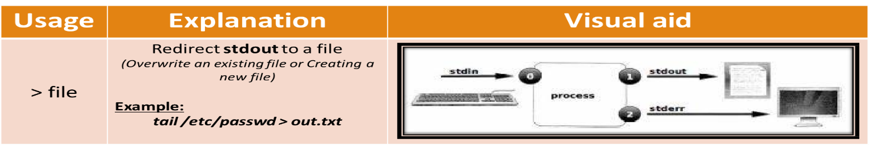***Ch4: Creating, Viewing, and Editing Text*** Files Redirecting Output to a File or Program

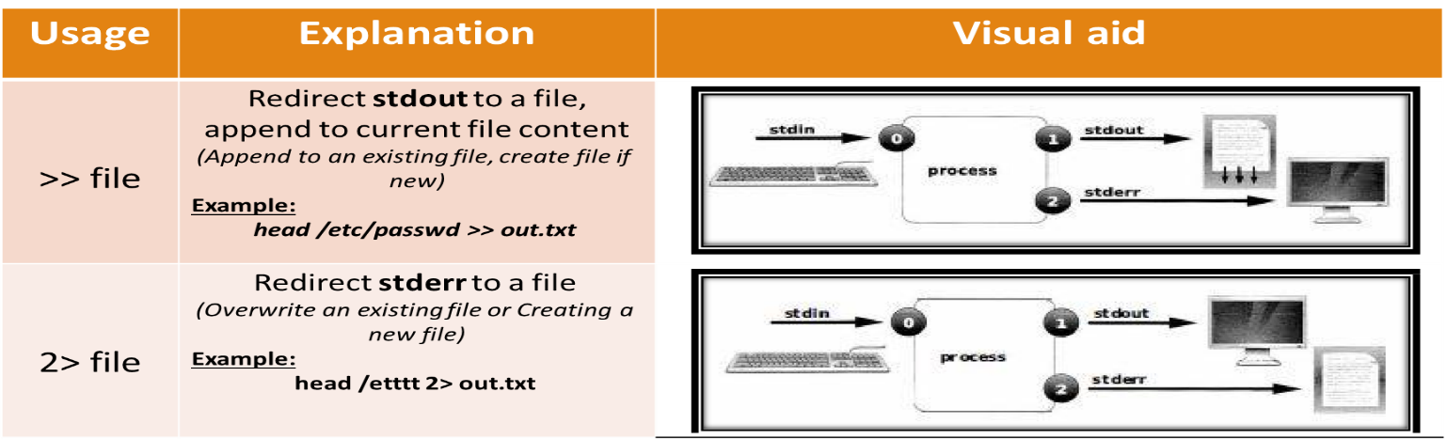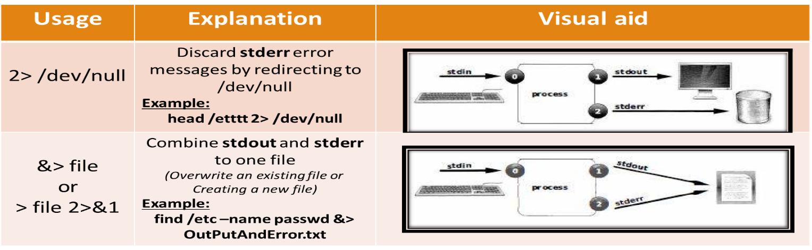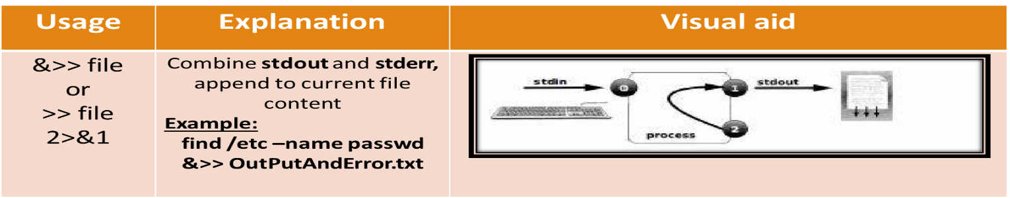

***Vim Shortcuts***

Open a file with **Vim** filename

***Ch6: Managing Users and Groups:***

|  |  |
| --- | --- |
| Command or option | Description |
| id | Used to show information about currently logged-in |
| ps  ps -a  ps -u | **default** is to show only processes in the current shell  To view **all processes** with a terminal, we use **(-a)** option  To view the **user associated** with processes we use **(-u)** |

|  |  |
| --- | --- |
| Command or option | Description |
| su | Changes user but in same directory, if add option (-) changes to the new home dir |
| sudo | allows a user to be permitted to run a command as root  All commands executed using **Sudo** are logged by default at **/var/log/secure** |
| useradd | create new users with default parameters (in **/etc/login.defs**) with no passwd (***–u assigns UID manually***) |
| usermod *– [ option]* | To Modify a user |
| userdel | delete an existing user while keeping the home dir (-r removes the home dir) |

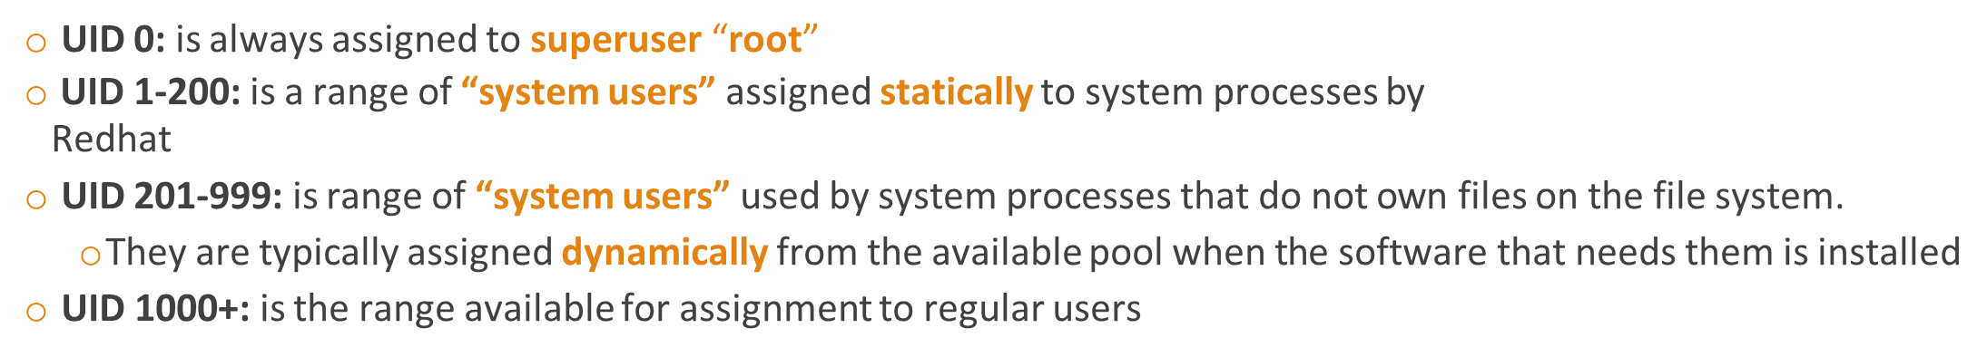

|  |  |
| --- | --- |
| Command or option | Description |
| groupadd | create a groups (**–g *GID*** option is used to specify a specific GID) |
| groupmod | **modify existing groups (–n option is used to specify a new name, -g for the GID)** |
| groupdel | used to remove group (may not be removed if it is the **primary group** of any user) |

***Managing User Passwords***

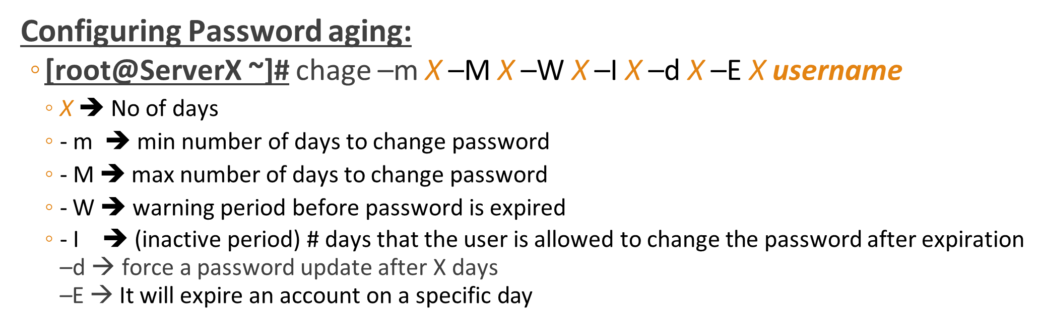

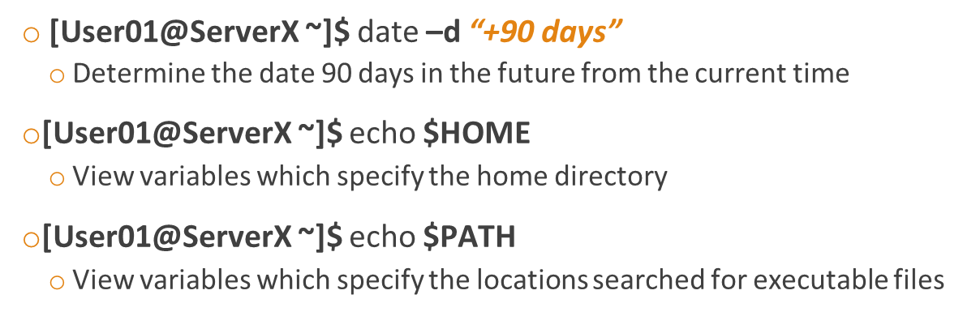

***Ch 6: System Permissions***

|  |  |
| --- | --- |
| Command or option | Description |
| chmod *WhoWhatWhich file* | *dir* | Who : u, g, o, a, What : +, -, = ,Which : r, w, x |
| chmod ### file | directory | **# is sum of r = 4, w=2 and x =1 Permissions are represented by a 3-digit**  **(or four, when setting advanced permissions) octal number** |
| chown *user:group file| dir* | used to change **ownership** of both **owner** and **group**  –R option to **recursively** changes the ownership of an entire directory tree. |

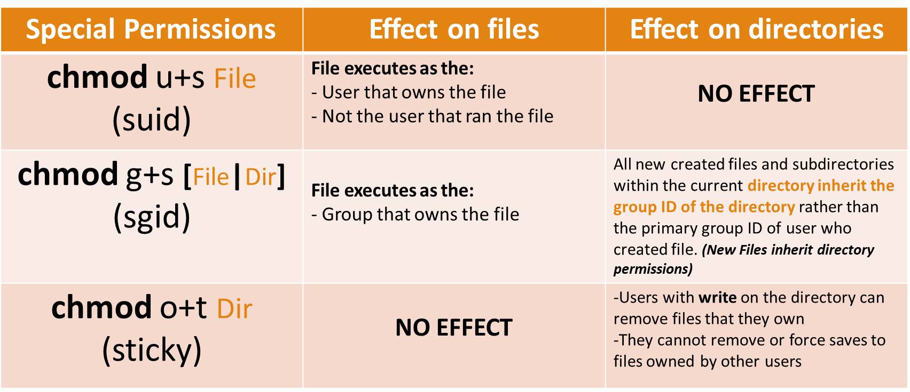

***Bash Scripting***

* **export** PATH=$PATH:$(pwd)

***Ch8: Monitoring and Managing Linux Processes***

A process is a running instance of a launched, executable program .Any application becomes a process

when it is executed.

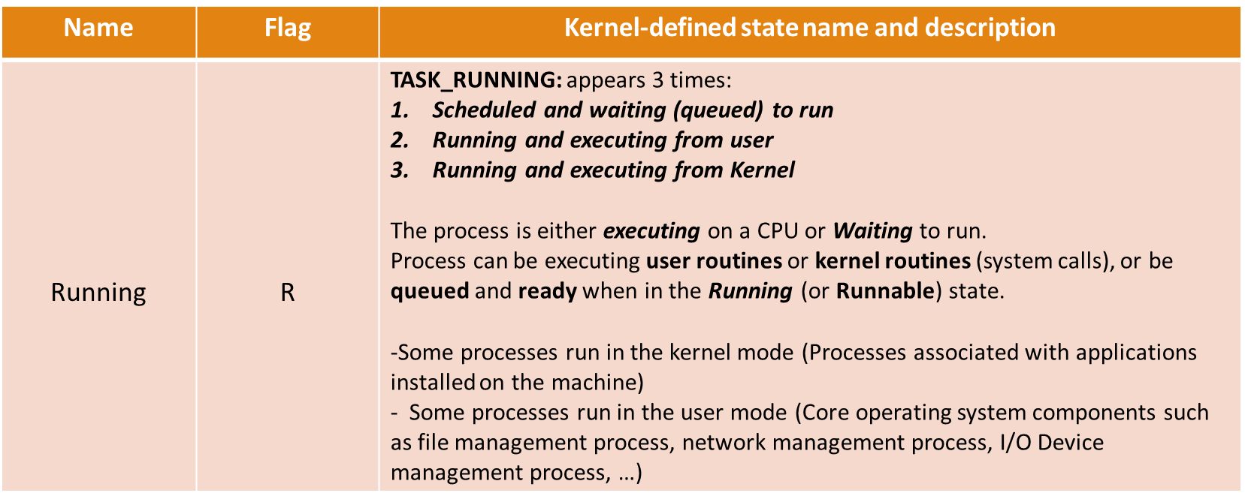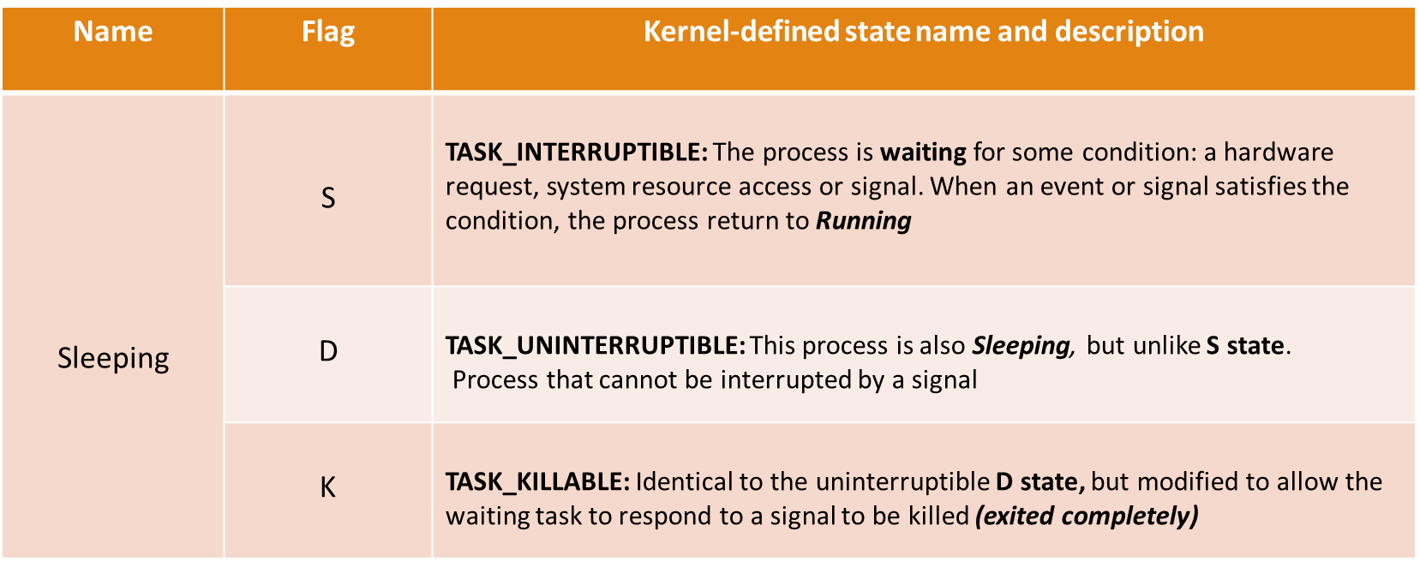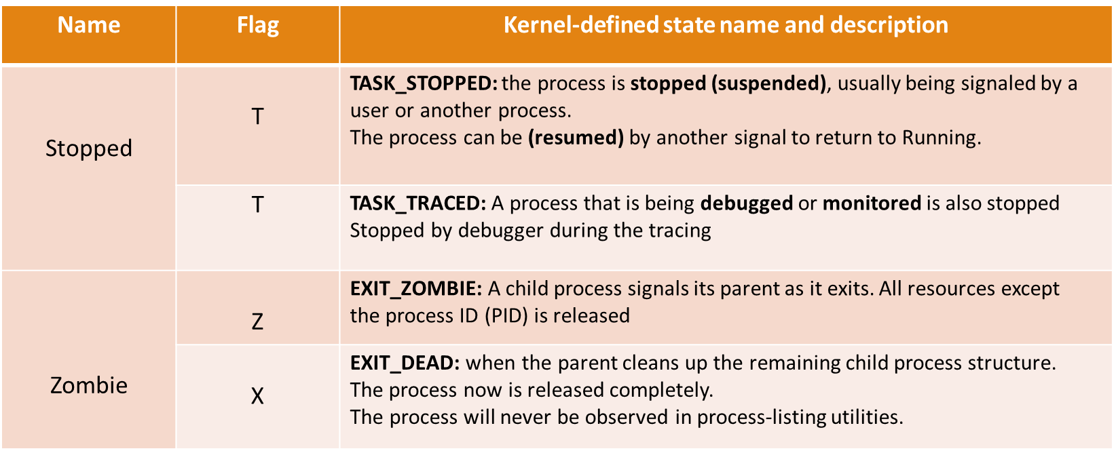

|  |  |
| --- | --- |
| Command or option | Description |
| ps  ps -aux | **-a :** prints the running processes from all users  **-u :** shows user or owner column in output  **-x :** prints the processes those have not been executed from the terminal  **-e**: provides summarized overview of running processes [PID, TTY, TIME, CMD]  **-f**: print the detailed overview(full format)[UID,PID,PPID, STIME,TTY,TIME,CMD] |
| Pstree -p user | **Shows all processes of user as a tree** |
| jobs | command is used to show the running processes in the background |
| fg % job_number | used to bring the process that is in the background to run in the foreground |
| bg % job_number | will start the suspended process running in the background |
| Ctrl + z | is used to stop and move the foreground process to the background |
| Ctrl + c | **Kill this process** |
| Ctrl + \ | **Core dump this process** |

|  |  |
| --- | --- |
| **Column** | **Description** |
| USER | The user account under which this process is running |
| PID | Process ID of this process |
| %CPU | CPU time used by this process (in percentage) |
| %MEM | Physical memory used by this process (in percentage) |
| VSZ | Virtual memory used by this process (in bytes) |
| RSS | Resident Set Size, the non-swappable physical memory used by this process (in KB) |
| TTY | Terminal from which this process is started. Question mark (?) sign represents that this process is not started from a terminal |
| STAT | Process state. *Explained in next table* |
| START | Starting time and date of this process |
| TIME | Total CPU time used by this process |
| COMMAND | The command with all its arguments which started this process |

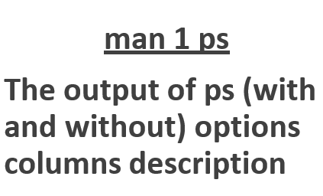

|  |  |
| --- | --- |
| Command or option | Description |
| Kill #PID  *Kill –signal_name # PID* | Kill by process ID  -l lists the control signals *–signal_name sends a specific signal* |
| Killall *command_pattern*  Killall *–signal command_pattern*  Killall *–signal –u username command_pattern* | it is used to send a signal to one or more processes matching selection criteria such as:   * Command name * Processes owned by specific user * All system-wide processes |
| pKill *command_pattern*  pKill *–signal command_pattern*  pKill *–signal –G GID command_pattern*  pKill *–P PPID command_pattern*  pKill *–t terminal_name –U UID command_pattern* | can signal multiple processes. Pkill uses advanced selection criteria which can include combinations of:   * **Command :** processes with ***pattern matching command name*** * **UID :** processes owned by a Linux ***user account*** * **GID :** processes owned by a Linux ***group account*** * **Parent :** child processes of a ***specific parent process*** * **Terminal :** Processes running on a ***specific controlling terminal*** |
| W -f | views **users currently logged into the system and their cumulative activities** |
| pgrep | with options ( -l and -u) is used to list all processes associated with a user |

***Ch9: SERVICES AND DAEMONS***

|  |  |
| --- | --- |
| Command or option | Description |
| *systemctl status name.type* | **unit type** is not provided, **systemctl** will show the status of a service unit |
| *systemctl –t help* | list of available unit types can be displayed |
| *systemctl --type=service* | To query the state of only the service units |
| *systemctl is-active name* | determine if a particular unit is active |
| *systemctl is-enabled name* | determine if a particular unit is enabled |
| *systemctl list-units --type=service --all* | List the loaded active units. Optionally, limit the type of unit. --all option will add inactive units |
| *systemctl list-unit-files* | View the enabled and disabled settings for all units. --type=, limits the type |
| *systemctl --failed* | View only failed units. Optionally, limit the type of unit. |
| *Systemctl [stop/start/restart]* | *stop/start/restart a service by name.* |
| *Systemctl reload name* | *reload**configuration file without complete stop and start.PID will not change* |
| *systemctl list-dependencies unit* | *print a tree of the units need to be started if the specified unit is started.*  *To show reverse dependencies, you can add the* ***--reverse*** *to the command.*  ***--before*** *and* ***--after*** *options, which can be used to show units that depend on the specified unit starting before and after themselves* |
| *Systemctl mask unit* | *Completely disable a service from being started. use* ***unmask*** *to revert it.* |

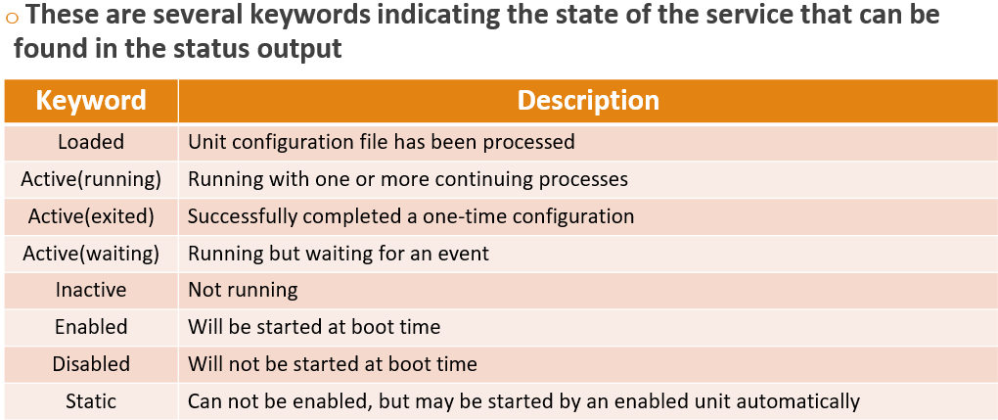

***Ch11:Networking***

|  |  |
| --- | --- |
| Command or option | Description |
| *ip addr* | ***show all interfaces*** |
| *ip addr show Int_Name* | ***show a specific interface*** |
| *ip –s link show Int_Name* | ***show statistics about network performance*** |
| *ip route* | ***Routing table*** |
| *ping –c3 ip_address* | ***-c3 is an option that limits the number of packets sent*** |
| *Traceroute*  *or tracepath* | ***The traceroute command has options to trace the path with:***  ***UDP (default), ICMP (-I), TCP (-T)*** |
| *ss* | ***is used to display socket statistics***   |  |  | | --- | --- | | -n | Show numbers instead of names for interfaces and ports | | -t | Show TCP sockets | | -u | Show UDP sockets | | -l | Show only listening sockets | | -a | Show all (listening and established) sockets | | -p | Show the process using the sockets | |
| *nmcli con show* | ***display a list of all connections (for active connections, add - - active option)*** |
| *nmcli con show name* | ***specify a connection ID (name) to see the details of that connection*** |
| *nmcli dev status* | ***show device status and details*** |
| *nmcli dev show name* | ***show a certain device details*** |
| *nmcli con add [….]* | ***con-name connection_name type connect_type ifname device_name autoconnect***  ***[Yes/No]******type type******ipv4 IPv4_address/prefix******gw4 gateway_address*** |
| *nmcli con up name* | ***Change to the new connection*** |
| *nmcli dev disconnect Device_Name* | ***To administratively disable an interface and prevent auto connection*** |
| *nmcli con mod name […..]* | ***Change any attribute of the connection. u can also use +/- another_configuration_argument (+ipv4.dns 8.8.8.8)*** |

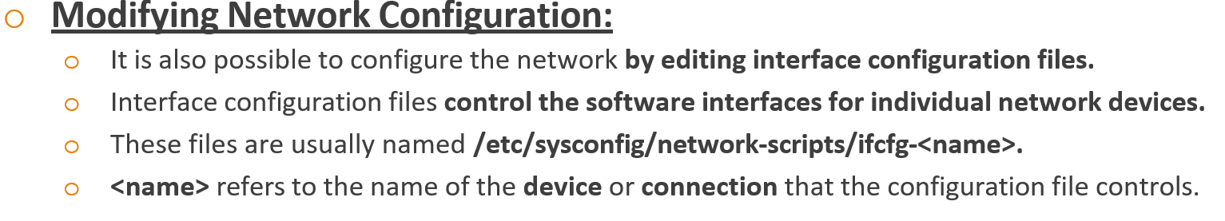





|  |  |
| --- | --- |
| Command or option | Description |
| *hostnamectl set-name ###* | ***command is used to change the hostname at /etc/hostname file*** |
| *hostnamectl status* | ***command is used to show the system’s fully qualified hostname*** |



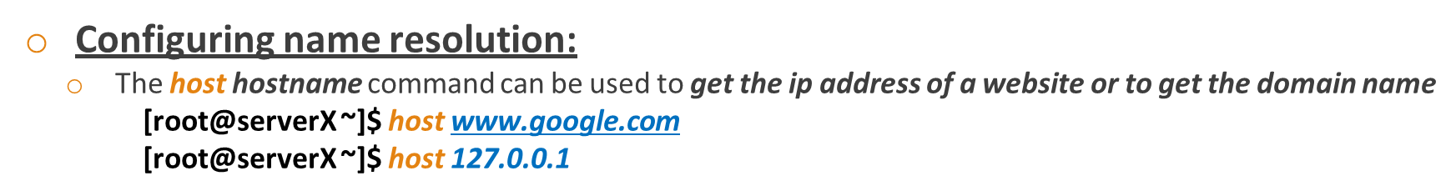

***Ch10:Logs and File system:***

|  |  |
| --- | --- |
| ***Systemd-journald Service*** | ***rsyslog Service*** |
| Logs are saved in non-persistent files | Logs are saved in persistent files |
| As they are saved in binary file at **/run/log/journal**  directory | These files are saved at **/var/log** directory |
| Provides an improved log management service that collects messages from the kernel which represents the early stages of the boot process, standard output and error of daemons as they start up and run | While logs at /var/log that are collected and recorded by rsyslogd service are used for any ordinary system or process tasks (Wrong Password Entry, stopping and starting of process, …….) |

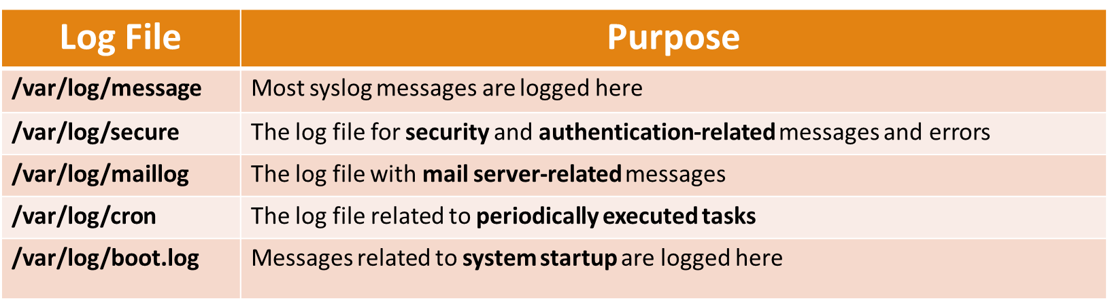

|  |  |  |
| --- | --- | --- |
| ***Code*** | ***Keyword*** | ***Description*** |
| ***0*** | ***kern*** | ***Kernel messages*** |
| ***1*** | ***user*** | ***Generic user-level messages*** |
| ***2*** | ***mail*** | ***Messages from mail daemons*** |
| ***3*** | ***daemon*** | ***Messages from system daemons without separate facility*** |
| ***4*** | ***auth*** | ***Used for non-system authorization messages*** |
| ***5*** | ***syslog*** | ***Used messages generated internally by syslogd*** |
| ***6*** | ***lpr*** | ***Line printer subsystem*** |
| ***7*** | ***news*** | ***Network news system*** |
| ***8*** | ***cron*** | ***Clock demon*** |
| ***9*** | ***authpriv*** | ***security/authorization messages (private)*** |
| ***10*** | ***ftp*** | ***Messages related to file transfer protocol (FTP) daemon*** |
| ***16 - 23*** | ***local0 – local7*** | ***reserved for local use*** |
| ***-*** | ***\**** | ***Meaning any facility*** |
| ***-*** | ***none*** | ***Meaning no facility*** |

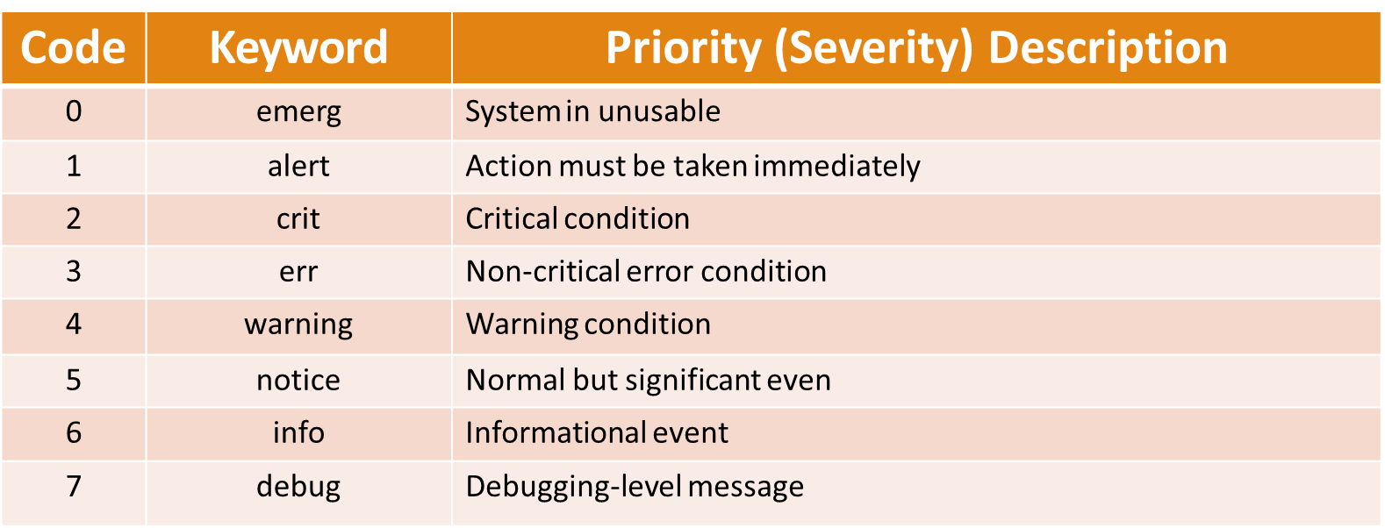

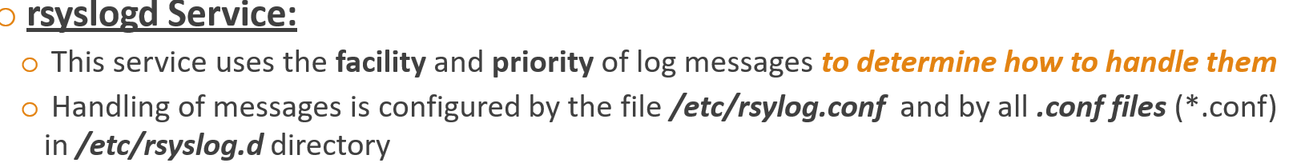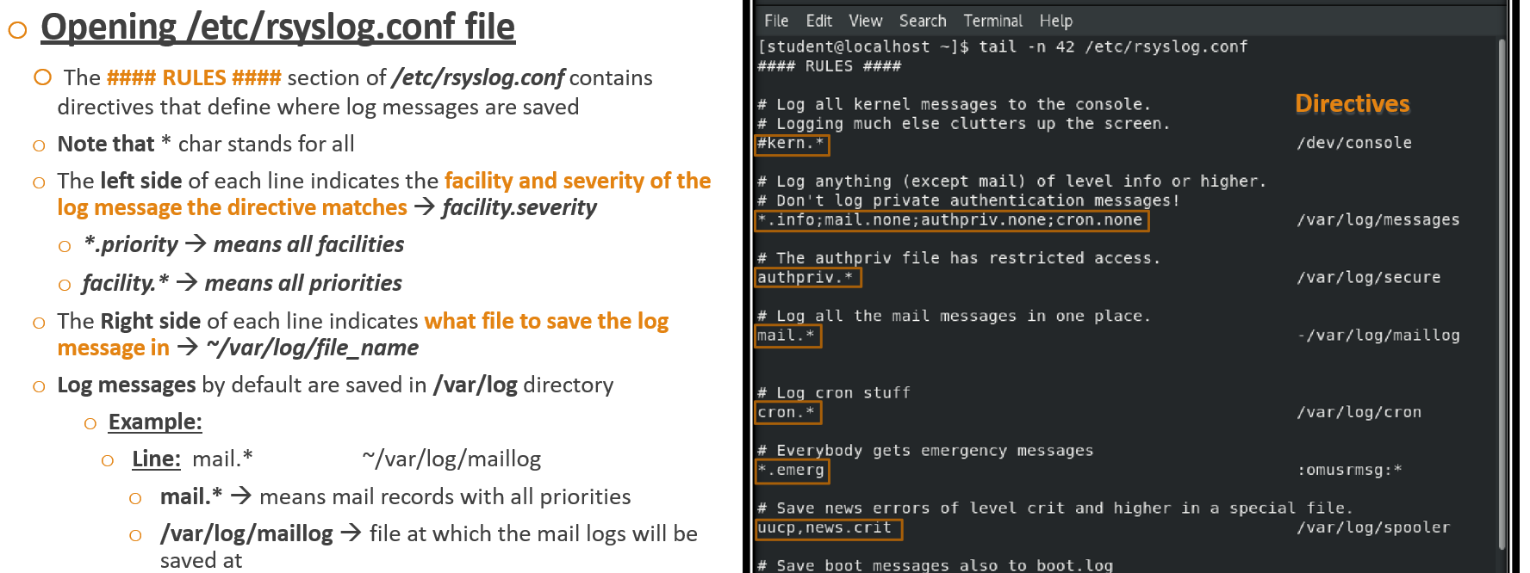

* + **Command Syntax: [root@localhost ~]# logger** ***-option facility.priority “Test Message”***
  + To send a message to **rsyslogd** that gets recorded in the **/var/log/boot.log** log file

, execute **[root@localhost ~]# logger** –p local7.notice “This is a Test Message”

|  |  |
| --- | --- |
| Command or option | Description |
| *journalctl* | ***shows the full system journal, starting with the oldest entry*** |
| *Journalctl _PID=3273* | ***shows the full system journal for PID 3273*** |



|  |  |
| --- | --- |
| Command or option | Description |
| *timedatectl* | shows an overview of the current time-related system settings  known time zones is available and can be listed using option **(list-timezones)** |
| *tzselect* | useful for identifying correct zoneinfo and time zone names |
| *timedatectl set-timezone* | adjust the time zone of the system  **adjust the time and date using**, the **set-time** “YYYY- MM-DD hh:mm:ss”  **set-ntp** option enables or disables NTP Synchronization for automatic time |

***Ch15 - Managing filesystems:***

|  |  |
| --- | --- |
| Command or option | Description |
| df | display an overview of local and remote file-system devices, which includes the total disk space, used disk space, free disk space, and the percentage of the entire disk space  **-h** option makes it readable. improves the readability of the output sizes. |
| du -h dir | more detailed information about a specific directory tree space. |
| lsblk | identify a Block Device  -fp lists the device full path, the UUIDs and mount points and the partition's file-system type. |
| mount /dev/vda4 /mnt/data | Mount File System with the Partition Name |
| mount UUID=”abc” /mnt/data | Mount the file system by the file-system UUID |
| unmount /mnt/data | Unmount File Systems |
| lsof | lists all open files and the processes that are accessing the file system |
| locate name | Locate Files by Name (-i option performs a case-insensitive search)  -n option limits the number of returned search results |
| Find /dir [option] name | -name option to return the path of files that match FILENAME exactly.  case insensitive-> -iname  -user and -group options search by a user(or UID) and group name(or GID)  -perm option looks for files with a particular permission set.  -size option is followed by a numeric value  -mmin option, followed by the time in minutes searches for all files with content that changed n minutes ago |
| Find /dir -type |  |